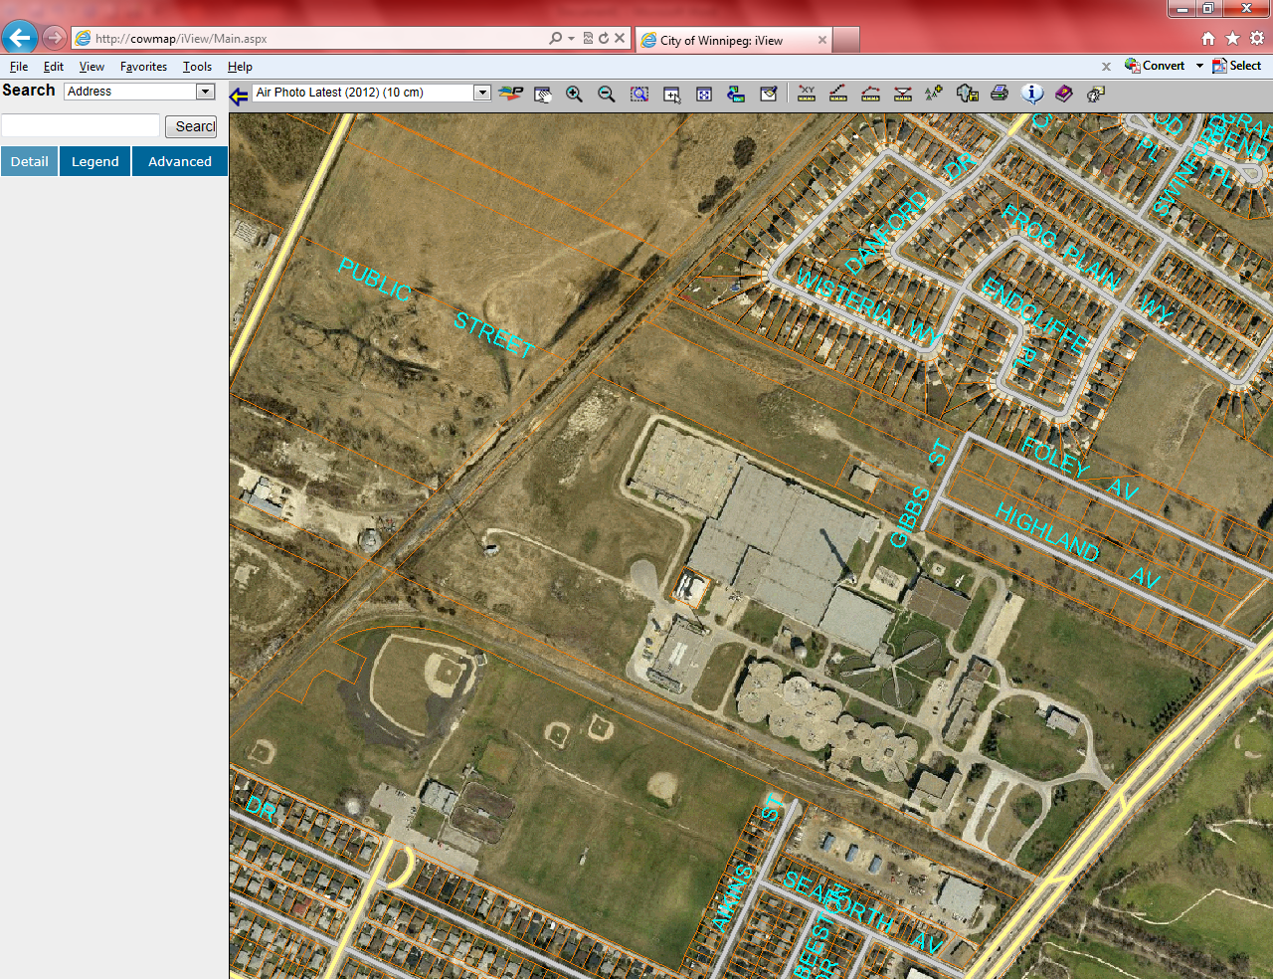

**Drawing 1**

**LOCATION OF SURVEY MONUMENTS**

Proposed Monument location

**PARCEL 1**

**MAIN STREET**

**PARCEL 2**

**FERRIER STREET**